**Summer Internship – 2025**

**By**

**Uptoskills**

**Duration :-** 6 Months

**Start Date :-** 6/12/2025

**End Date :-** __________

**Name :-** Sarthak Dangi

**Course :-** B.Sc (Hons) Forensic Science

**Interview Date :-** 6/12/2025

**Offer Letter Date :-** 6/12/2025

**Domain Team Leader :-** Mohit Saini

**Co Domain Team Leader :-** Ashutosh Maurya

**Project Name :-** Cyber Security

**Project Briefed :-** Nmap scanning & enumeration on Uptoskills target (Controlled & Safe Scan)

**Task – 5 Nmap Tool (Target Scanning Report)**

**Date of allotment :-** 6 January 2025

**Dead line :-** __________

**Objective**

To perform safe and basic Nmap scanning on the target website https://uptoskills.com/ to identify open ports and service details in a controlled and ethical manner.

**Tool Used**

Nmap (Network Mapper)  
Operating System: Kali Linux

**Target Details**

Target Website: https://uptoskills.com/  
Target IPs (Resolved via DNS): 104.21.77.200, 172.67.211.113 (Cloudflare CDN)

**Commands Used & Procedure**

**1) DNS Lookup (Target Resolution)**

**nslookup uptoskills.com**

This step was used to resolve the domain name into IPv4 and IPv6 addresses to identify the scanning targets.

**2) Web Ports Scan with Service Detection (IP: 104.21.77.200)**

**nmap -p 80,443 -sV -Pn 104.21.77.200**

This scan checked the HTTP/HTTPS ports and detected service information using -sV. -Pn was used to skip ICMP ping checks.

**3) Web Ports Scan with Service Detection (IP: 172.67.211.113)**

**nmap -p 80,443 -sV -Pn 172.67.211.113**

This scan verified open ports and services on the second resolved Cloudflare IP for the same domain.

**4) Safe NSE Script Scan (IP: 104.21.77.200)**

**nmap -p 80,443 --script safe -Pn 104.21.77.200**

This scan ran Nmap Scripting Engine safe-category scripts for additional non-intrusive information gathering.

**5) Save Output to Text File (For Proof)**

**nmap -p 80,443 -sV -Pn 172.67.211.113 -oN uptoskills_nmap_172.txt**

This command saved the scan output into a text file for documentation and submission evidence.

**Findings**

• Port 80/tcp was found OPEN (HTTP) on Cloudflare edge servers.  
• Port 443/tcp was found OPEN (HTTPS / SSL) on Cloudflare edge servers.  
• Service detection identified 'cloudflare' as the service provider (CDN / reverse proxy).  
• Target appears protected behind Cloudflare which hides the original server IP.

**Result**

Nmap successfully identified open web service ports and basic service information for uptoskills.com through its Cloudflare IP addresses.

**Ethical Consideration**

The scanning was performed strictly for educational purposes and in a safe manner (limited to web ports and safe scripts only). No exploitation was performed.

**Screenshots (Practical Proof)**

**Screenshot 1: DNS Resolution using nslookup (uptoskills.com)**

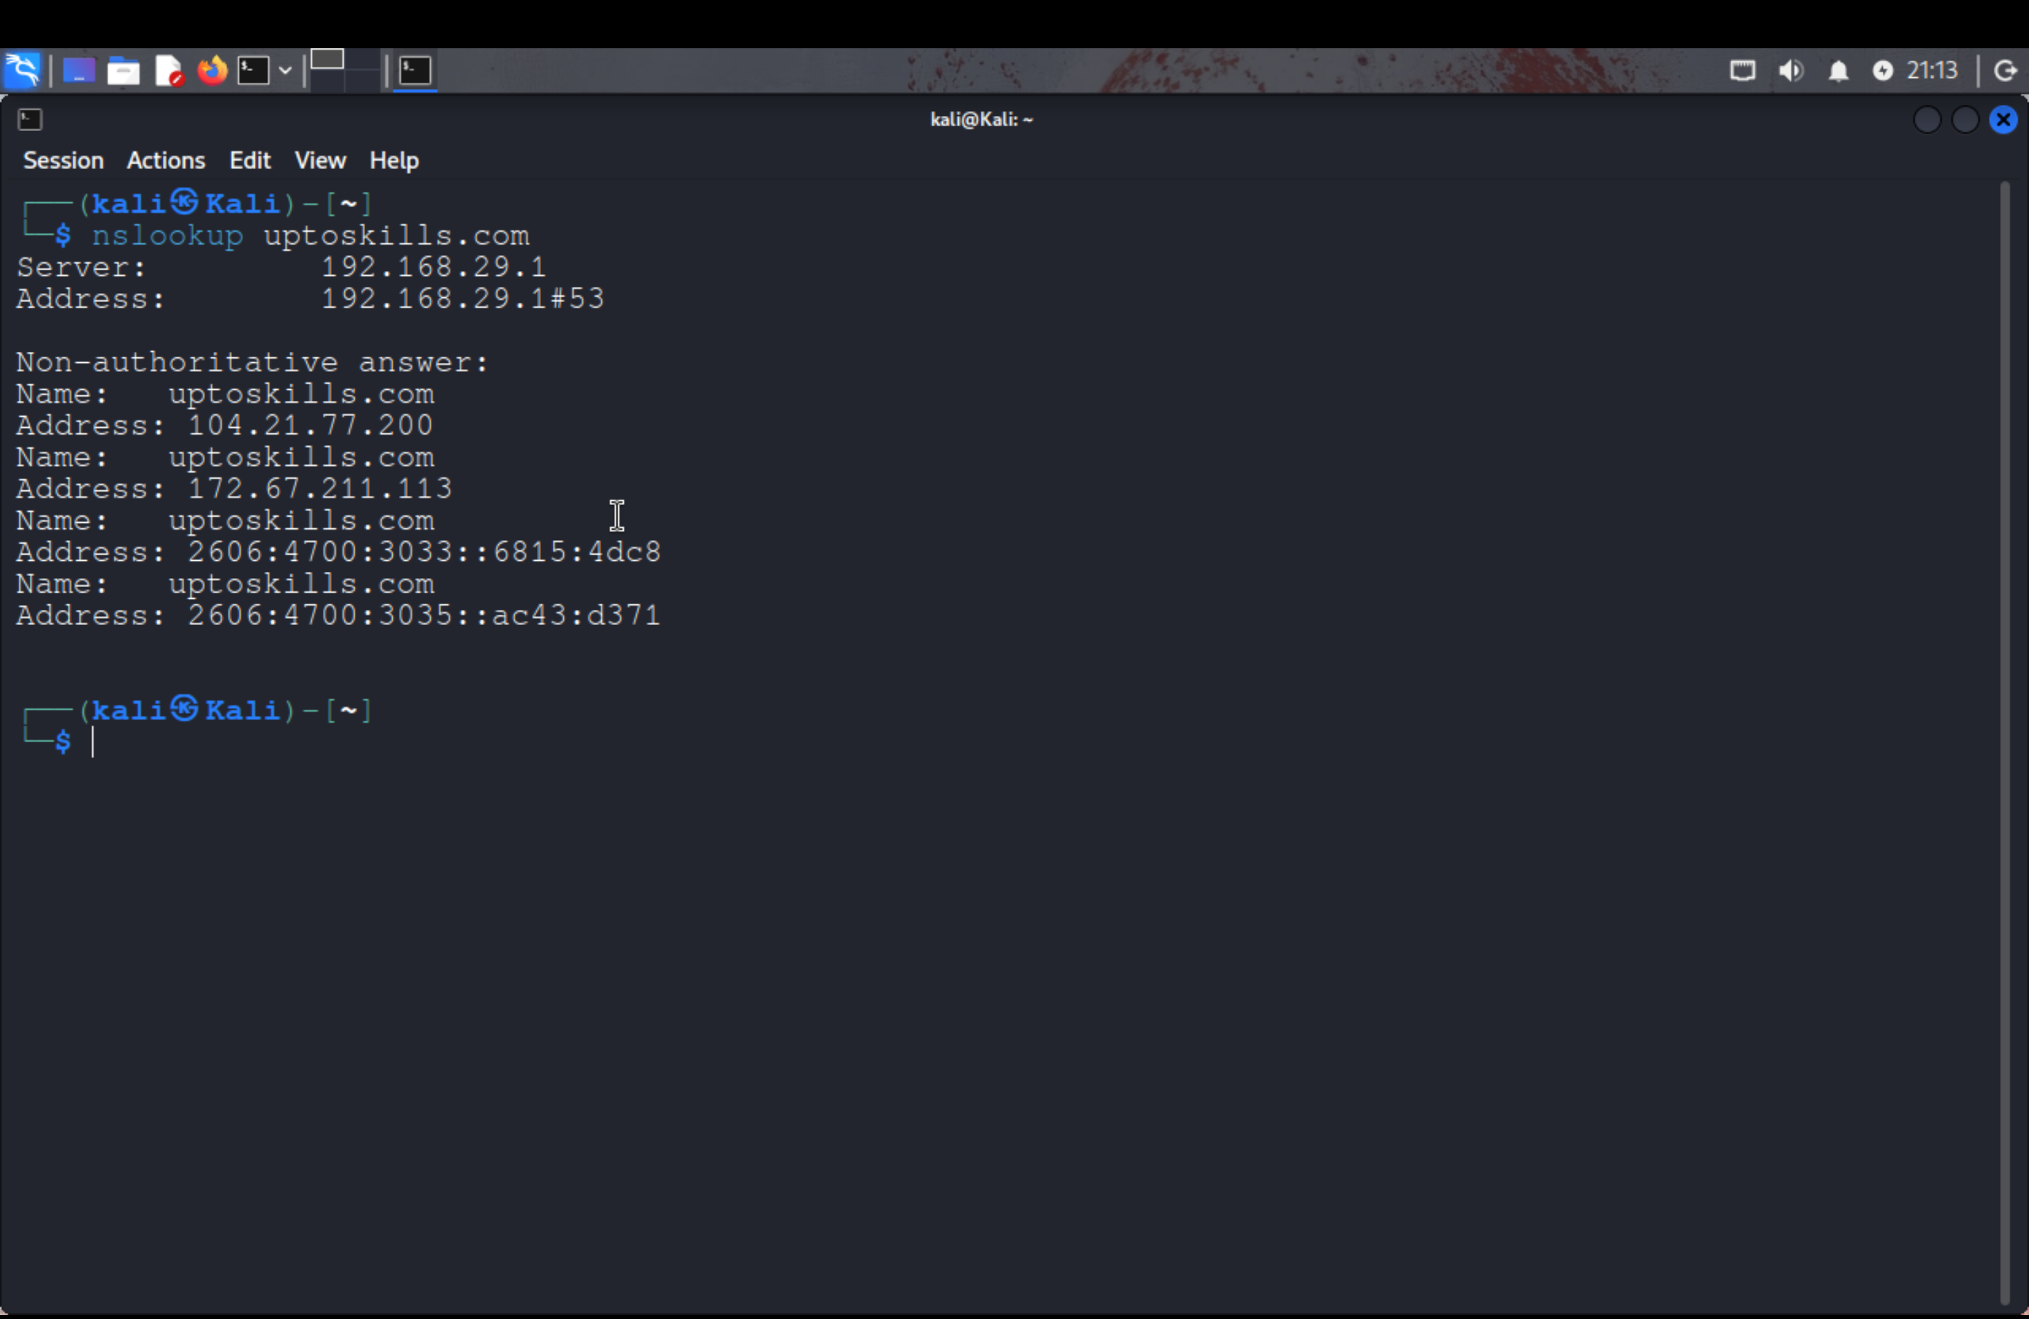

We resolved uptoskills.com to multiple IPv4/IPv6 addresses which belong to Cloudflare CDN.

**Screenshot 2: Nmap scan on 104.21.77.200 (Ports 80,443 + Service Detection)**

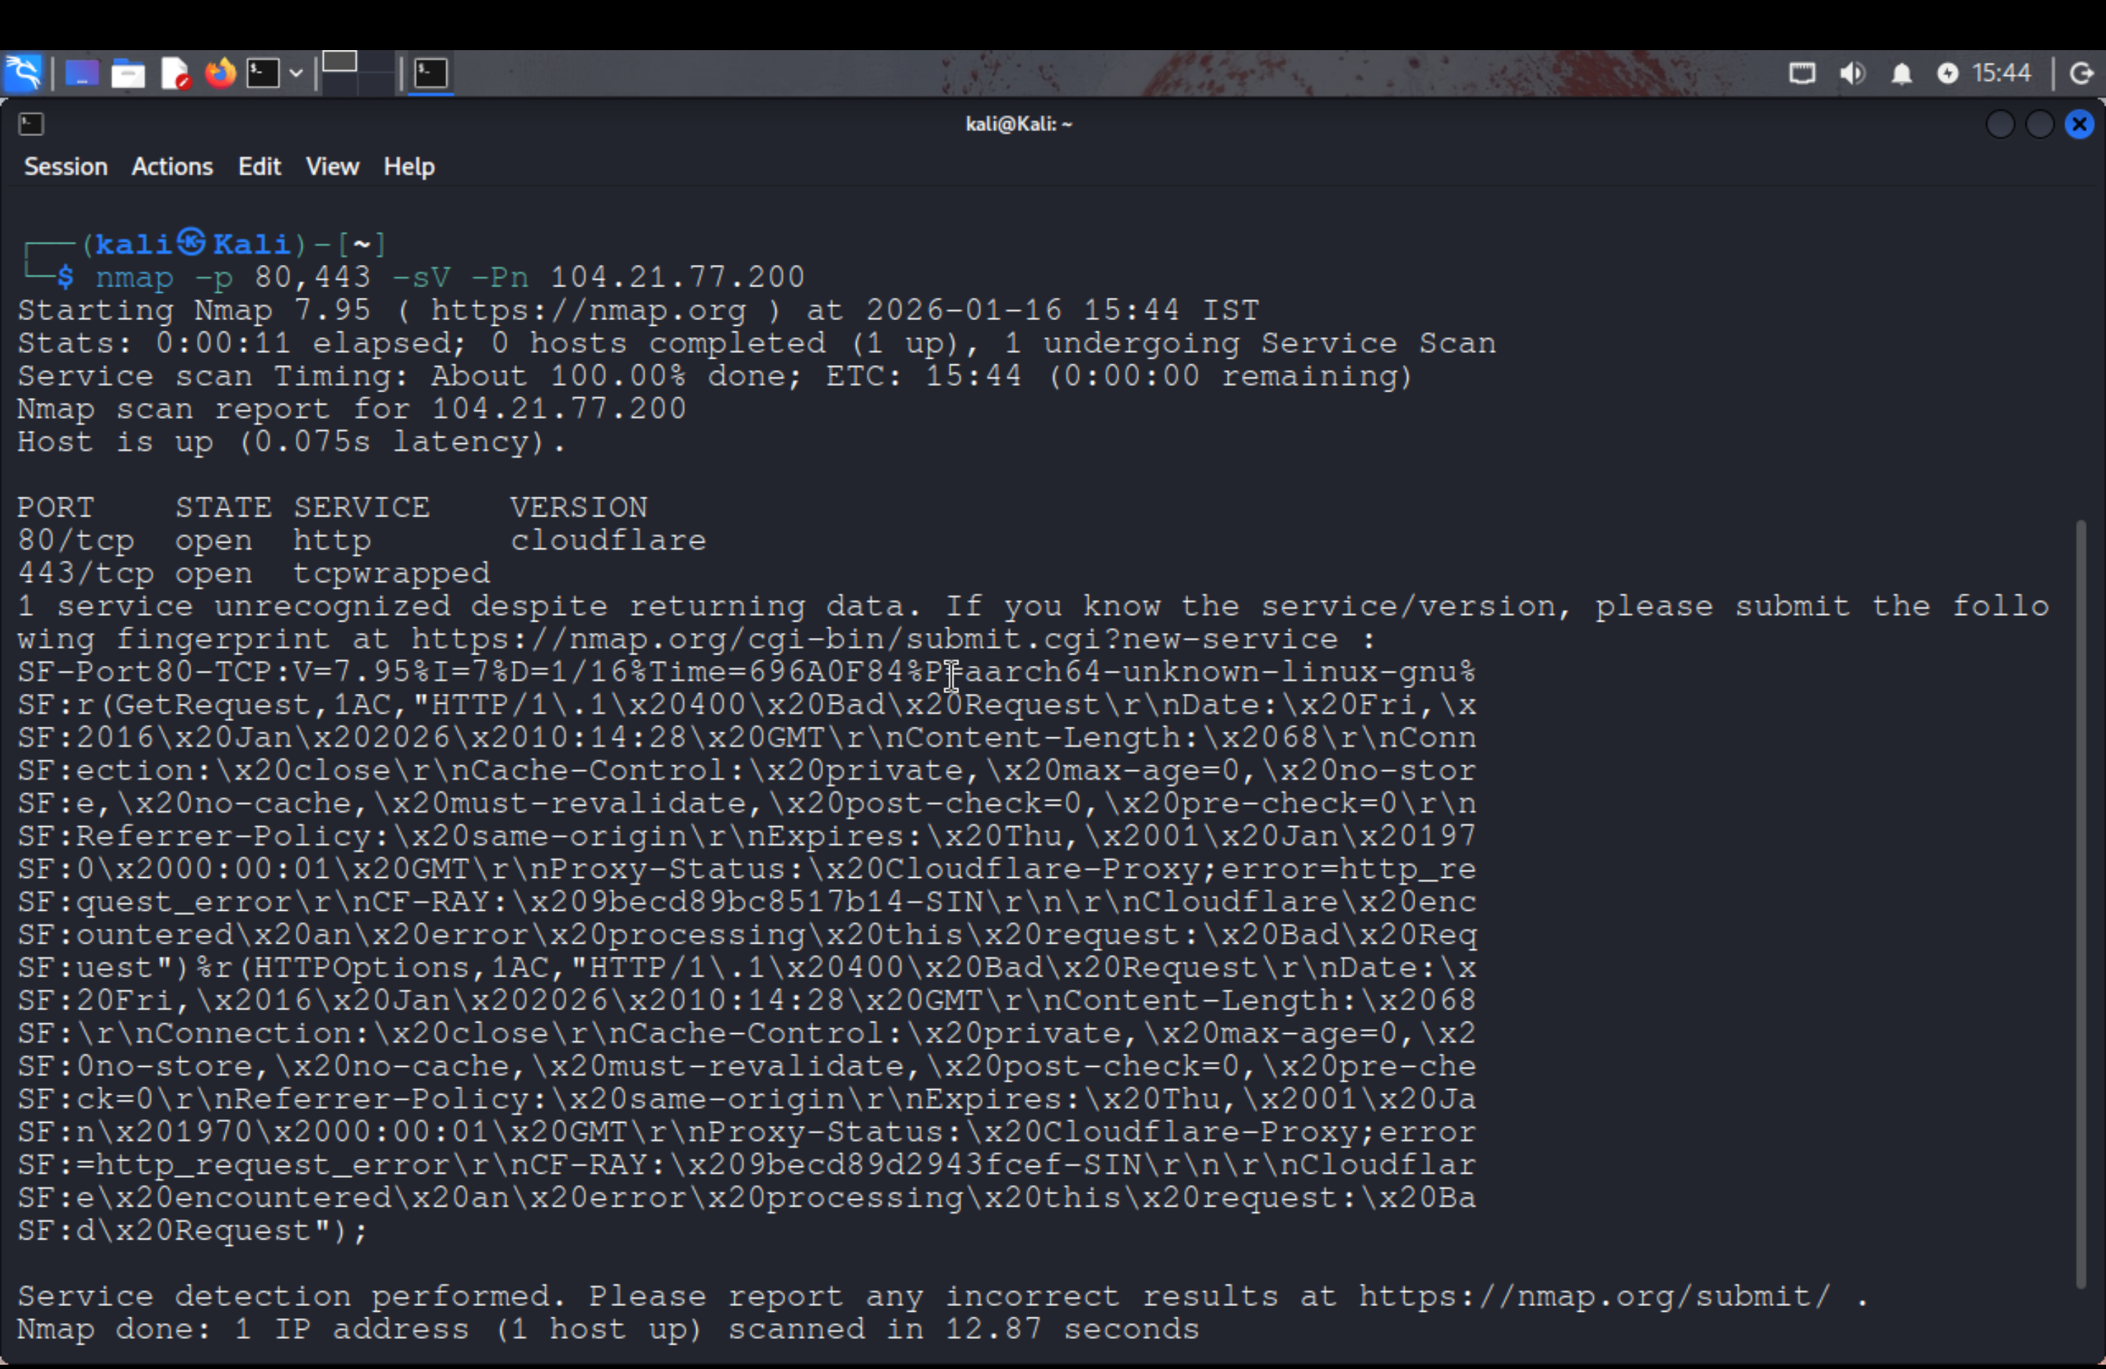

We scanned HTTP/HTTPS ports and observed Cloudflare service on port 80 and port 443 open.

**Screenshot 3: Nmap scan on 172.67.211.113 (Ports 80,443 + Service Detection)**

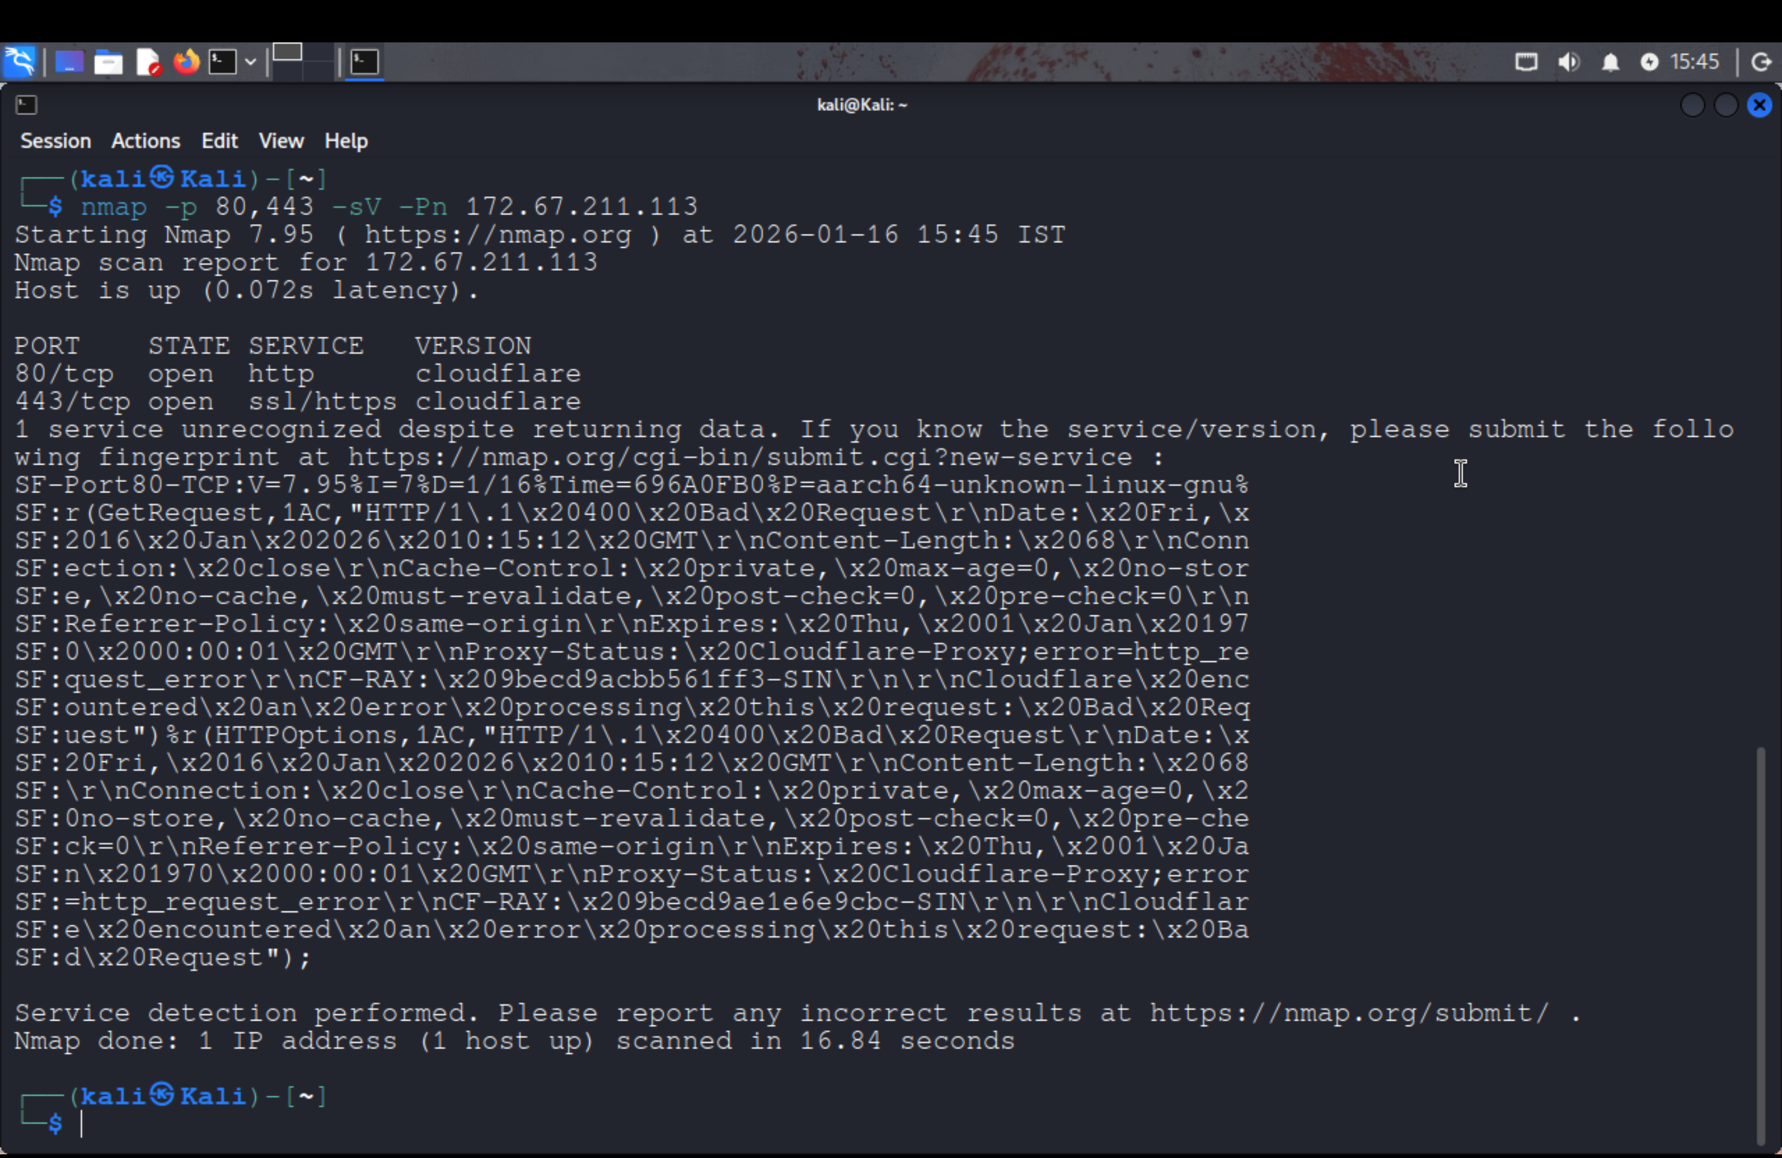

We verified the second Cloudflare IP and confirmed ports 80 and 443 are open with Cloudflare services.

**Screenshot 4: Nmap Safe NSE Script Scan (104.21.77.200)**

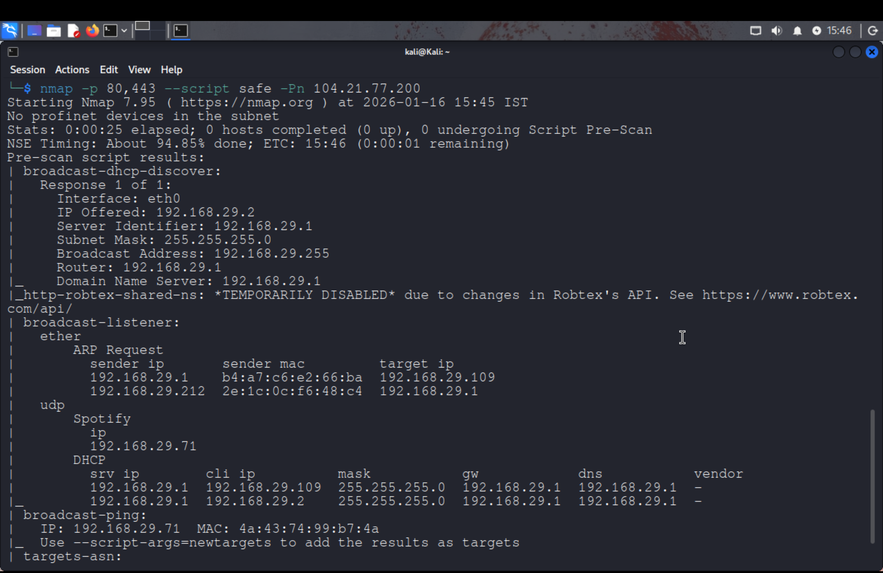

We ran Nmap safe scripts to gather additional information without performing intrusive actions.

**Screenshot 5: Safe Script Scan Output (Continuation)**

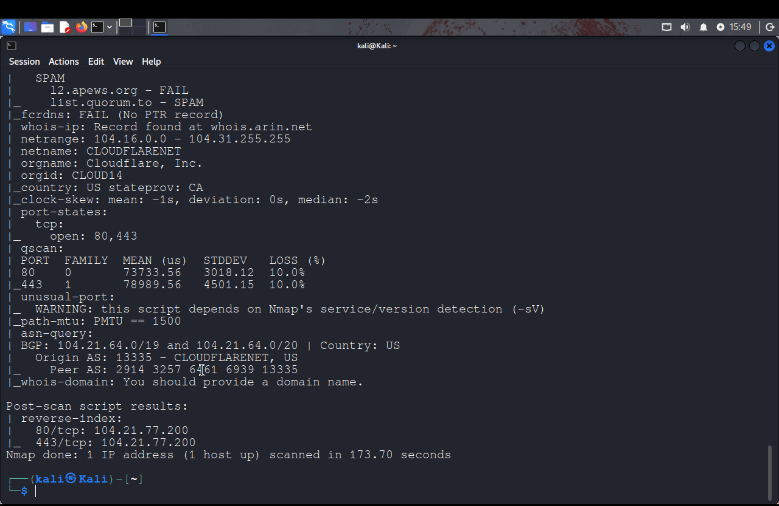

This output shows Cloudflare ASN/port states and scan details obtained from safe scripts.

**Screenshot 6: Output Saved to File (uptoskills_nmap_172.txt)**

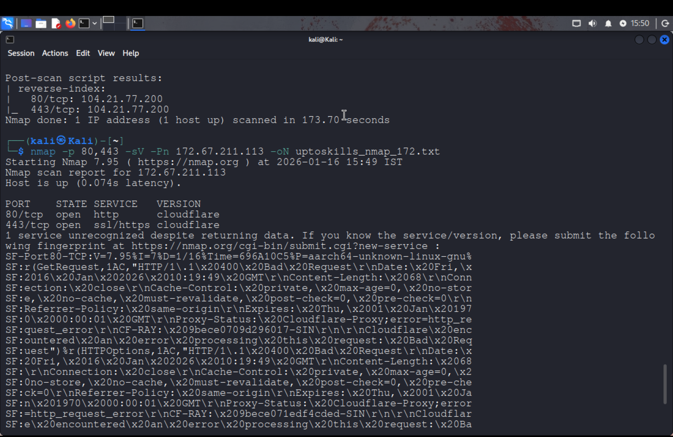

We saved scan results in a text file for report documentation and proof of execution.